Urban Micro-Brewery Development Planning

Andrew Cox

May 29th, 2019

1. Abstract

Micro-brewery development has been increasing in the Charlotte Metropolitan area for over ten years now, totaling greater than 40 breweries. Charlotte has been rated the third fastest growing city in America set to increase 47% from 2010 to 2030. With the increase in resident’s year over year the development of infrastructure has also increased year over year to accommodate this growth. Considering this growth, this study looks at the locations of the various breweries, the transportation services (CATS – Charlotte Area Transportation Service) available, as well as industrial property for sale in an effort to minimize distance to a mass transportation service, minimizing property cost for new development, as well as maximizing customers by analyzing foot traffic in the area. The final deliverable will allow an (brewery) investor to make an educated decision on where to construct a micro-brewery and what their potential revenue opportunity may be.

1.1 Business Problem

A new investor would like to develop a micro-brewery within the city of Charlotte, North Carolina which will add to the +40 currently in the city. The investor wants to identify an optimal location which maximizes customers by identifying highly traveled areas of the city throughout the day, identifies a location where public transportation is close by, and is within close proximity to other venues and breweries. Several alternatives should be proposed as a final deliverable, so the investor can make an intelligent decision.

1. Data Sources

While harnessing the power of Foursquare data, there will be other manual and automated data sources that will be utilized in determining the outcome alternative for investment location. Below are a few data sources and how they will be utilized:

1. **Foursquare:** Utilized for extracting brewery location data in Charlotte.
2. **Google Maps/Analytics:** Utilized for identifying highly trafficked areas at various times of the day. This can also be used to pin-point certain venues and capture their traffic during the day (busy times) at certain times. A Manual data set will be generated for at least 3 breweries per each cluster relating to High/Med/Low times foot traffic levels for Monday through Sunday.
3. **NCDOT AADT Mapping Application:** This application will be utilized to analyze the various transportation routes in Charlotte, NC to identify if a transportation route is near the potential brewery location.

<http://ncdot.maps.arcgis.com/apps/webappviewer/index.html?id=5f6fe58c1d90482ab9107ccc03026280>

1. **Charlotte Area Transit System:** Utilized for understanding the specific mass transit routes around the greater charlotte area. Data will be generated based on distance to mass transit pickup/dropoff locations.
2. **LoopNet.com**: This website will be utilized for identifying commercial/industrial lease space and prices around the greater charlotte area. Square footage and price data will be captured.

2.1 Data Acquisition

One requirement of this project was to utilize Foursquare data. With that being said, almost all breweries were listed within foursquare and could be queried utilizing the foursquare API. A Side by side comparison was executed utilizing a google maps query in parallel with a Folium generated map of the foursquare API. When we wanted to seek the mass area transportation system routes, we utilized CATS website as well as the NCDOT AADT Mapping Application to observe the various transportation services around the area. Again, google was utilized to gather “optimal” times of the day and days of the week and was manually entered into a spreadsheet for analysis. All of the industrial properties that could be breweries were found on LoopNet.com, which gave the square footage of the building, lot size, location, type of property and if it was a sale or lease. These properties were also added to a spreadsheet and minimized based on cost and maximized based on square footage.

2.2 Data Manipulation

Of the data gathered, I had to be creative with how I was able to convert “Pedestrian Traffic” from attribute data to variable data in an effort to create a measurable metric. Harnessing the power of Google, a module exists for each venue called “popular times” within the web browser. It lists the days of the week as well as hours of the day where population density is low to when it is high. I coded the following for each rating: “Closed” -0, “Usually Not Busy” - 1, “Usually Not Too Busy” – 3, “Usually a Little Busy” – 5, “Usually as Busy as it Gets” - 7/9 as there are two levels for the highly populated venue. Of the clustered postal codes, a sample of two breweries were taken from each of the clusters as analyzing all breweries would be cumbersome since this was a manual process. A cat plot of the pedestrian traffic will be explored within section “2.3 Exploratory Data Analysis.”

Foursquare was queried to search for “Brewing” within 8000 meters of center city and listed all breweries within the greater Charlotte uptown boundary. The dataframe was scrubbed to remove the residential services, food trucks, and lawyers that ended up within the query totaling 22 breweries within the Charlotte uptown area. The results were mapped utilizing folium to give us a geospatial representation of the brewery locations based on their latitude and longitude (see Figure 1 and Table 1). One hot encoding was executed for the breweries postal codes for preparation in developing the brewery clusters.

The CATS information was utilized as a visual representation to gain a greater understanding of the current mass transportation pickup locations. During the data acquisition, it was found that the “Blue Line” light rail was the main method of mass transportation system which cuts through the center of the city and would allow transportation to many of the breweries. Given this information, I utilized the Blue Line as a benchmark to derive the walking score for each property listed on LoopNet. The walking distance (miles) was then calculated, utilizing google maps from pickup location to potential property locations, and a rank was given based on the potential property with the least distance to mass transportation system.

All of the loopnet data was used as is and was entered into a spreadsheet manually. Manipulation was minimal and only consisted of reorganizing within the spreadsheet based off of postal codes and filtering out properties where they were not industrial and any property <3000 SF as it wouldn’t be large enough for the industrial brewing equipment and seating area.

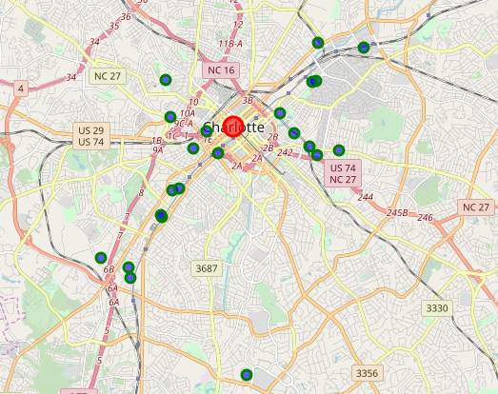

**Geospatial Representation - Figure 1**

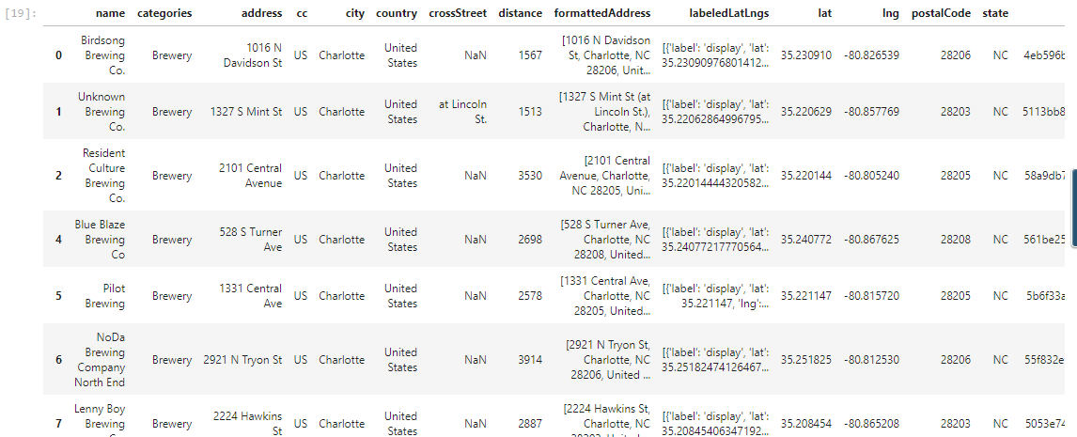

**Scrubbed Dataframe - Table 1**

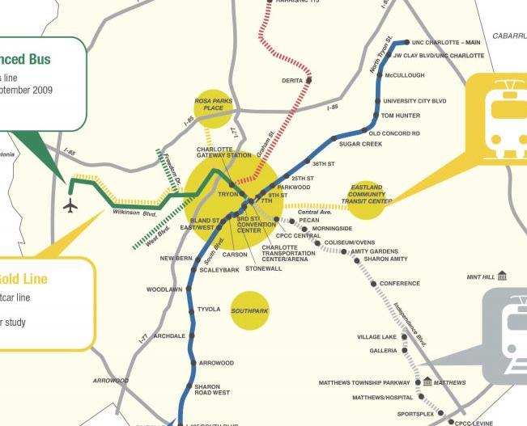

**Lynx Blue Line Map - Figure 2**

2.2 Exploratory Data Analysis/Modeling

The main focus was to narrow down a location where there is high foot traffic and ease of access to the light rail in order to optimize future business opportunity. A machine learning algorithm called K-means was utilized in order to cluster the breweries into three clusters by Postal Codes - Figure 3 shows the clustered breweries. Taking the foot traffic dataframe manually generated, I created a cat plot (Figure 4) based on the sampled breweries and day of the week while also running descriptive statistics for each brewery. What I found was the greatest foot traffic mean turned out to be “Cluster 1” (purple) with a mean of 5.07 throughout the week. Analyzing this data allowed me to focus in on Cluster 1, which yielded more popular venues and was comprised of the following postal codes: 28205, 28204, 28202, 28203. This data was utilized in searching for industrial properties on LoopNet.

After querying loopnet.com, I found that there were almost no industrial properties available for lease within Cluster 1, which is believed to be caused by the already developed micro-breweries within that area. This forced me to expand my search outward, mainly within 28206 postal code which is part of Cluster 2 (Teal-upper right). I manually entered all the industrial properties (total of 11) into a spreadsheet which calculated the total yearly lease as well as the walking distance/walking time from the property to the closest Blue Line station.

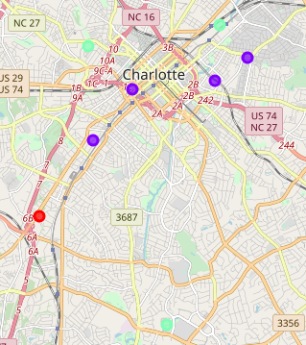

**K-Means Clustered Breweries – Figure 3**

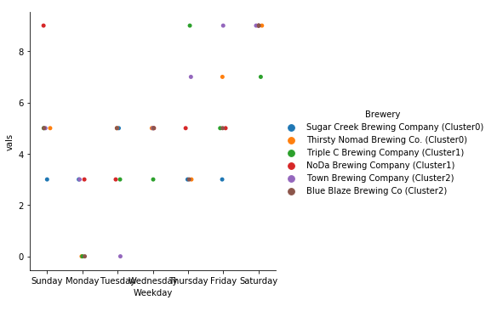

**Cat plot of sampled Brewery Foot Traffic Ratings – Figure 4**

Figure 5 shows an Scatter Plot of the total yearly lease cost per property. We can clearly see that paying >$100,000 in lease cost per year is not ideal for a new micro-brewery, therefore we will need to explore the data further. Exploring the data further, we can group the properties by zip code and see how the zip code plays a part in square footage, square foot cost, and distance to light rail in order to understand the relationship. The goal is to optimize all variables by maximizing square footage, maximizing foot traffic, minimizing total cost, and minimizing walking distance.

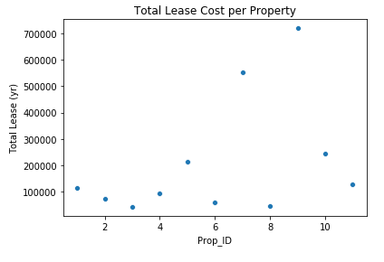

**Total Lease Cost per Property - Figure 5**

By creating a box plot (Figure 6) of the square footage based on the zip code, we can see that 28208 has the greatest range in square footage while 28203 has the smallest range. We cannot make a determination based on this variable alone, so we will need to look further into different variables in parallel. Figures 7 and 8 displays box plots of the total yearly lease cost and total walking time (in minutes) from the closest light rail station, respectively. Analyzing the various box plots, we can almost certainly remove all the properties from the 28208-zip code as they consist of the greatest annual lease with a mean of $363,775 and an average walking time of 58 minutes (2.8 mi). We also can see that properties within 28208 are very large (>120,000SF) and would be infeasible for micro-brewery equipment but would tailor more towards a large-scale brewery operation.

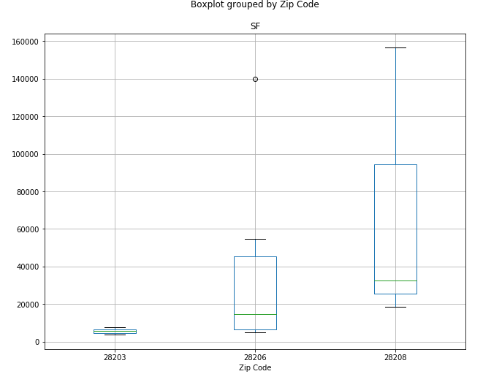

**Square Footage Box Plot based on Zip Code - Figure 6**

Narrowing down on 28206 and 28203, we can see that 28203 properties are very limited on size averaging ~5,700 SF and yields the lowest annual cost of ~$80,000. Looking at the walk time, 28203 also has the lowest travel time of 10 minutes (0.45 mi). 28206 has the most options in regards to properties and has and average size of ~39,000 SF and average annual cost of ~$173,000. Comparing walk times, 28206 has an average of 16-minute walk time (0.8 mi) to the nearest blue line station which is also a manageable distance. Let’s minimize the variables and filter the properties further narrow down potential locations:

1. **Address:** 1420 S Mint St. **Zip:** 28203, **SF:** 7656, **Total Lease (yr):** $114,840, **Walk Time:** 11 minutes
2. **Address:** 432 Foster Ave. **Zip:** 28203, **SF:** 3754, **Total Lease (yr):** $45,048, **Walk Time:** 9 minutes
3. **Address:** 216 W 24th St. **Zip:** 28206, **SF:** 5000, **Total Lease (yr):** $42,500, **Walk Time:** 7 minutes
4. **Address:** 453 Atando Ave. **Zip:** 28206, **SF:** 11835, **Total Lease (yr):** $58,585, **Walk Time:** 7 minutes
5. **Address:** 1217 Tryon St. N **Zip:** 28206, **SF:** 5000, **Total Lease (yr):** $75,000, **Walk Time:** 16 minutes

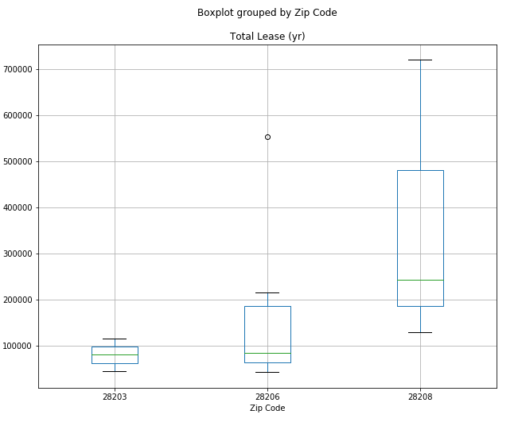

**Total Yearly Lease Cost Boxplot - Figure 7**

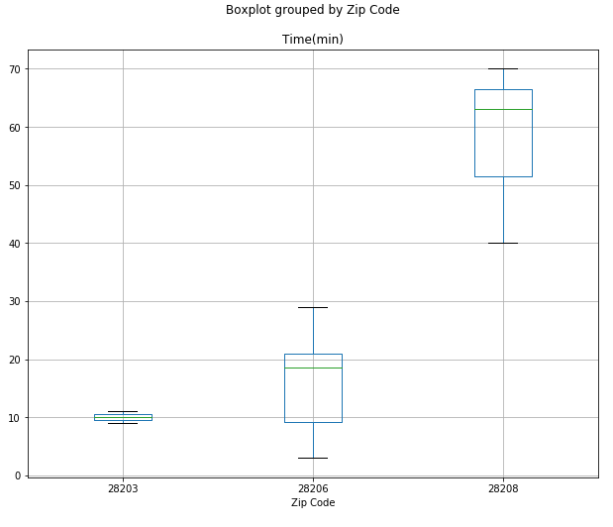  
**Total Walking Time Boxplot from Light Rail - Figure 8**

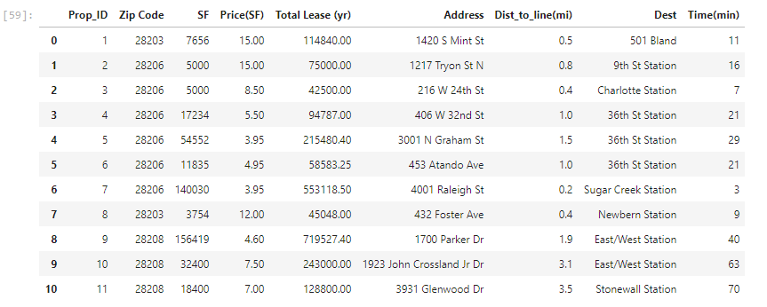

**Properties Dataframe – Table 2**

Now to make a better educated decision, we need to run some analysis to determine the potential micro-brewer’s production capacity and associated revenues based on the square footage available for each property. Assumptions will be made based on various articles and information found on the internet along with removing any OPEX costs and startup costs as we are going to assume they are constant from one property to the other.

For space requirements, we are going to allocate 70% of the available square footage to the brewing system (piping, instrumentation, and controls) and will split the remaining 30% into dry storage and seating areas. Several sources estimate that space requirements are 0.5-1.0 SF/bbl of yearly capacity with a median of 1.6 SF/bbl and 2.16 SF/bbl using 99%CL. For this calculation we will utilize the median value of 1.6. A bbl has the capacity of 248 pints of beer which we will use the average cost per pint of beer at $5/pint and will reduce the total capacity by 20% to allow for beer tasting, growler fills, as well as spills and other unforeseen issues. After constructing a simple spreadsheet, we can calculate these numbers and maximize the “Revenue” associated with each property (Table 3).

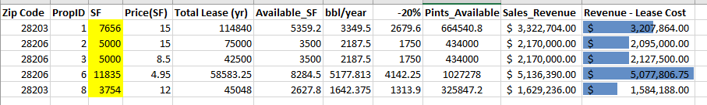

**Potential Revenue based off Beer Capacity and Sales - Table 3**

Based off of the calculation, we can clearly see that Property 6 (located at 453 Atando Ave.) would maximize the potential annual revenue while property 1 would be the next runner up. If we recap back on the walking distance we can see that Property 6 has a walk time of 21 minutes (1 mile) and Property 1 of 11 minutes (0.5 miles). Below is a graph of both properties represented in Google Maps. Both are within an optimal location and would be of manageable distance from the uptown Charlotte area.

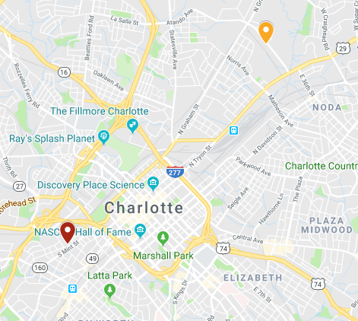

**Top Potential Property Locations- Figure 9**

3.0 Conclusions

To recap, in this study we searched foursquare for brewery locations around the Uptown Charlotte area. We then used a ML K-means algorithm to cluster the breweries based on densities. After, we engineered features to analyze popular venues and assigned a score for each of the samples. This allowed us to narrow down the location areas, and designate certain zip codes as “popular” areas. We gathered all industrial properties for lease around the uptown area and calculated the distance to the main light rail “Blue Line” which cuts through the heart of uptown and is able to transport customers to the various venues. This technique allowed us to narrow down the search to a handful of properties for further filtering. Finally, we calculated the potential revenue based on the square footage of the property and looked for a property with the highest revenue.

From all the data acquisition, manipulation, and calculation, we found that two properties stood out the most, 453 Atando Ave and 1420 S Mint St. Either of these properties would be an optimal choice however it is up to the developer if they would like to look into any other properties. The benefit is, the framework is outlined in this report and methods can be duplicated if needed in the future from developer to developer.

4.0 References

1. World Population Review, *Charlotte, North Carolina Population 2019*

<http://worldpopulationreview.com/us-cities/charlotte-population/>

1. Micro Brewr, *“How Big Should my Brewery Be?”*

<https://microbrewr.com/how-big-should-my-brewery-be/>

1. BrewBound, *“Beer Business Finance: Breaking Down the Taproom-Focused Brewery Model”*

<https://www.brewbound.com/news/beer-business-finance-breaking-down-the-taproom-focused-brewery-model>

1. ICC Northwest, “*Beer Tanks and Systems”*

<https://jvnw.com/beer/>

1. LoopNet, *“Find Your Next Commercial Property”*

<https://www.loopnet.com/>

1. Scikit Learn, “sklearn.cluster.KMeans”

<https://scikit-learn.org/stable/modules/generated/sklearn.cluster.KMeans.html>